From Life on the Mississippi by Mark Twain (http://www.gutenberg.org/files/245/245-h/245-h.htm)
TEXT ONE: excerpts from ch. 44, “City Sights”
Background: In this part of Twain’s memoir, he visits New Orleans after having spent many years abroad. He meets up with some old friends and they discuss the particularities of Southern life. Twain begins this chapter with a reflection on what New Orleans means to him, a city he once referred to as the only European city in America. Life on the Mississippi was first published in 1883.
THE old French part of New Orleans—anciently the Spanish part—bears no resemblance to the American end of the city: the American end which lies beyond the intervening brick business-center. The houses are massed in blocks; are austerely* plain and dignified; uniform of pattern, with here and there a departure from it with pleasant effect; all are plastered on the outside, and nearly all have long, iron-railed verandas running along the several stories. Their chief beauty is the deep, 5 warm, varicolored stain with which time and the weather have enriched the plaster. It harmonizes with all the surroundings, and has as natural a look of belonging there as has the flush upon sunset clouds. This charming decoration cannot be successfully imitated; neither is it to be found elsewhere in America. [ . . . ]
Thousands of people come by rail and carriage to the [Spanish part of New Orleans] every evening, and dine, listen to the bands, take strolls in the open air under the electric lights, go sailing on the lake, and entertain themselves in various and 10 sundry* other ways. [ . . . ]
* * *
A Southerner talks music. At least it is music to me, but then I was born in the South. The educated Southerner has no use for an “r,” except at the beginning of a word. He says “honah,” and “dinnah,” and “Gove’nuh, and “befo’ the waw,” and so on. The words may lack charm to the eye, in print, but they have it to the ear. When did the “r” disappear from Southern speech, and how did it come to disappear? The custom of dropping it was not borrowed from the North, nor inherited from 15 England. Many Southerners—most Southerners—put a “y” into occasional words that begin with the “k” sound. For instance, they say “Mr. K’yahtah” (Carter) and speak of playing “k’yahds” or of riding in the “k’yahs.” And they have the pleasant custom—long ago fallen into decay in the North—of frequently employing the respectful “Sir.” Instead of the curt Yes, and the abrupt No, they say “Yes, Suh,” “No, Suh.”
But there are some infelicities*. Such as “like’ for “as,”* and the addition of an “at” where it isn’t needed*. I heard an 20 educated gentleman say, “Like the flag-officer did.” His cook or his butler would have said, “Like the flag-officer done.” You hear gentlemen say, “Where have you been at?” And here is the aggravated form*—heard a ragged street Arab* say it to a comrade: “I was a-ask’n’ Tom whah you was a-sett’n’ at.” [ . . . ] They say “reckon.” They haven’t any “doesn’t” in their language; they say “don’t” instead. The unpolished often use “went” for “gone.” [ . . . ]
We picked up one excellent word—a word worth traveling to New Orleans to get; a nice limber, expressive, handy word—25 “lagniappe.”* They pronounce it lanny-yap. It is Spanish—so they said. We discovered it at the head of a column of odds and ends in the Picayune*, the first day; heard twenty people use it the second; inquired what it meant the third; adopted it and got facility in swinging it the fourth. It has a restricted meaning, but I think the people spread it out a little when they choose. It is the equivalent of the thirteenth roll in a “baker’s dozen.” It is something thrown in, gratis*, for good measure. The custom originated in the Spanish quarter of the city. When a child or a servant buys something in a shop—or even the 30 mayor or the governor, for aught I know*—he finishes the operation by saying—
“Give me something for lagniappe.”
The shopman always responds; gives the child a bit of licorice-root, gives the servant a cheap cigar or a spool of thread, gives the governor—I don’t know what he gives the governor; support, likely.
When you are invited to drink, and this does occur now and then in New Orleans—and you say, “What, again?—no, I’ve had 35 enough.” The other party says, “But just this one time more—this is for lagniappe.” When the beau* perceives that he is stacking his compliments a trifle too high, and sees by the young lady’s countenance that the edifice* would have been better with the top compliment left off, he puts his “I beg pardon—no harm intended,” into the briefer form of “Oh, that’s for lagniappe.” If the waiter in the restaurant stumbles and spills a gill of coffee down the back of your neck, he says “For lagniappe, sah,” and gets you another cup without extra charge.
austerely (2): | sundry (10): | infelicities (19): | “Such as…isn’t needed” (19): examples of the infelicities Twain perceives | aggravated form (21): I’m thinking Twain means the most Southern way of phrasing
a ragged street Arab* (21): Twain is describing someone who looks a little rough. This person is probably of Middle Eastern descent | lagniappe (25): something given as a bonus or extra gift. These footnotes are lagniappes. | Picayune (26): city in New Orleans | gratis (28): | aught I know (30)- Southern way of saying “all I know.” So he used local color in an essay about local color.
beau (35): | edifice (36):
TEXT TWO: from ch. 45, “Southern Sports”
We went to a cockpit* in New Orleans on a Saturday afternoon. I had never seen a cock-fight before. There were men and boys there of all ages and all colors, and of many languages and nationalities. But I noticed one quite conspicuous and surprising absence: the traditional brutal faces. There were no brutal faces. With no cock-fighting going on, you could have played the gathering on a stranger for a prayer-meeting; and after it began, for a revival—provided you blindfolded your 5 stranger—for the shouting was something prodigious*. [ . . . ]
A negro and a white man were in the ring; everybody else outside. The cocks were brought in in sacks; and when time was called, they were taken out by the two bottle-holders*, stroked, caressed, poked toward each other, and finally liberated. The big black cock plunged instantly at the little gray one and struck him on the head with his spur. The gray responded with spirit. Then the Babel* of many-tongued shoutings broke out, and ceased not thenceforth. When the cocks had been 10 fighting some little time, I was expecting them momently to drop dead, for both were blind, red with blood, and so exhausted that they frequently fell down. Yet they would not give up, neither would they die. The negro and the white man would pick them up every few seconds, wipe them off, blow cold water on them in a fine spray, and take their heads in their mouths and hold them there a moment—to warm back the perishing life perhaps; I do not know. Then, being set down again, the dying creatures would totter gropingly about, with dragging wings, find each other, strike a guesswork 15 blow or two, and fall exhausted once more.
I did not see the end of the battle. I forced myself to endure it as long as I could, but it was too pitiful a sight; so I made frank confession to that effect, and we retired. We heard afterward that the black cock died in the ring, and fighting to the last.
Evidently there is abundant fascination about this “sport” for such as have had a degree of familiarity with it. I never saw 20 people enjoy anything more than this gathering enjoyed this fight. The case was the same with old gray-heads and with boys of ten. They lost themselves in frenzies of delight. The “cocking-main” is an inhuman sort of entertainment, there is no question about that; still, it seems a much more respectable and far less cruel sport than fox-hunting—for the cocks like it; they experience, as well as confer enjoyment; which is not the fox’s case.
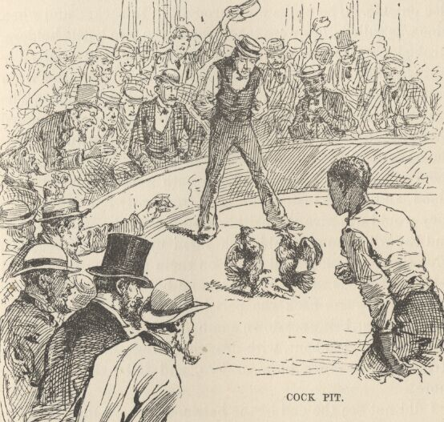 from the illustrated version of Life on the Mississippi
cockpit (1): Not for airplanes…a place to fight male chickens
prodigious (5):
two bottle-holders (7): Fingers? Two people who are holding bottles? All that matters is that the roosters are out of the bag, ready to fight.
Babel (9): probably meant babble which makes way more sense

