Unit Test Review name: _______________________

TEXT 1: Cartoon
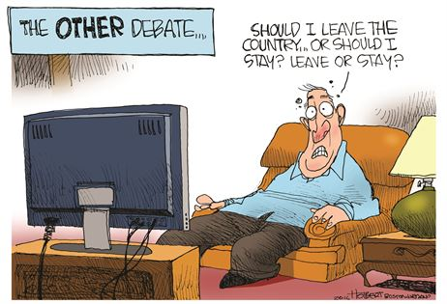

1. Who is the most likely audience for this cartoon?

2. What does the writer of this cartoon assume about his audience?

3. What logical fallacy is being used here?

4. What claim does this cartoon make?

TEXT 2: Patrick Henry (230), rhetorical devices, rhetorical appeals

TERM YOUR DEFINITION EXAMPLE FROM HENRY
Ethos

Pathos

Logos

Antithesis

Parallelism

TEXT 3: The Crisis by Thomas Paine

Read the biography for Thomas Paine on p. 248 and answer the questions below
1. What is Common Sense about?

2. What was different about how Paine delivered his message for independence? Whom did he address his message?

3. What was controversial about The Age of Reason?

Read lines 1-12 (“targeted passage 1”) on p. 250 and lines 22-30 (“targeted passage 2”) on p. 252 and answer the questions below
4. Explain the line “the harder the conflict, the more glorious the triumph” (4-5).

5. Paine describes “freedom” as “celestial” (7). How does this allude to his religious beliefs?

6. In lines 22-30, what argument does Paine make for why the Americans will win the war with Britain?

7. What metaphorical language does Paine use to characterize the King? What type of appeal is this?

TEXT 4: MLK’s “I Have a Dream” speech

1. Who is the “great American” King references (3)?

2. How does King prove that African Americans are “still [ . . . ] not free” (6)? What figurative language does he use? Explain any example from that paragraph.

3. What “check” is King claiming to cash (11)? What does he mean?

4. How has America “defaulted” on African Americans (14)?

5. Why would it be “fatal for the nation to overlook the urgency of the moment” (25)?

6. What purpose do lines 31-35 serve in advancing King’s rhetoric? How does it make King appear to his audience as a speaker?

7. What does King mean when he says “[w]e cannot walk alone” (40)? Who is he walking with?

8. How does King define the “American dream” (47)? What are the characteristics of it?

9. Explain King’s use of repetition beginning in line 48.

10. Who is King’s audience?

